231. Power of Two
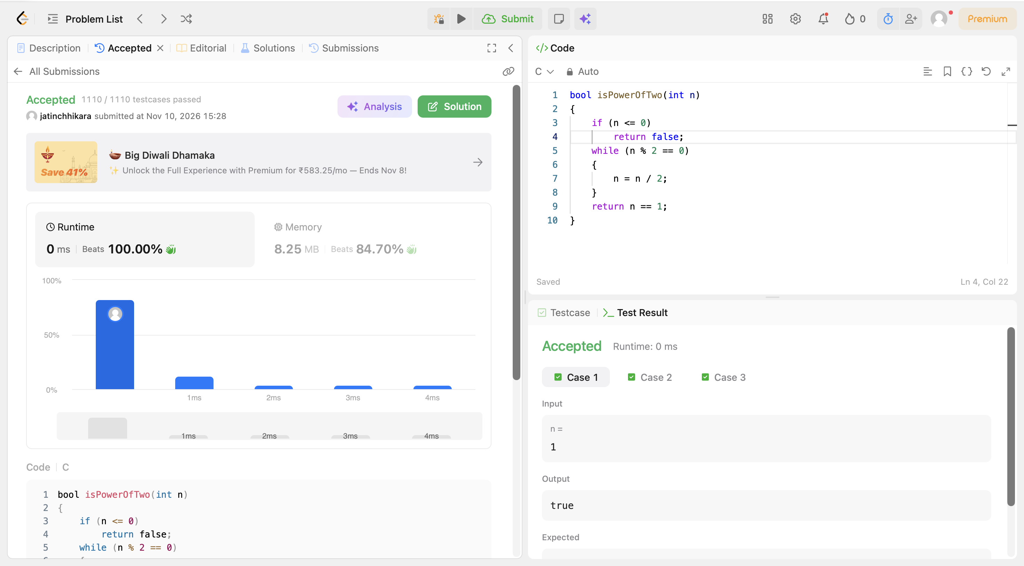
Code:
bool isPowerOfTwo(int n)
{
if (n <= 0)
return false;
while (n % 2 == 0)
{
n = n / 2;
}
return n == 1;
}

